

**Automated temperature controlled fan**

**A MINI PROJECT**

**REPORT**

*Submitted by:*

**Niranjan C – 1NH18EE731**

**Dhanush L – 1NH18EE716**

**Abhimanyu Iyer – 1NH18EE700**

***In partial fulfillment for the award of the degree of***

**Bachelors of Engineering (BE)**

**IN**

**Electrical & Electronics**

`

**DEPARTMENT OF ELECTRICAL AND ELECTRONICS ENGINEERING**

**BONAFIDE CERTIFICATE**

Certified that the Mini Project work entitled **“Automated temperature controlled fan”** carried out by **Niranjan C – 1NH18EE731 , Dhanush L– 1NH18EE716,Abhimanyu Iyer – 1NH18EE700”** are Bonafide students of New Horizon College of Engineering submitted the report in completion of project at Department of Electrical and Electronics Engineering, New Horizon College of Engineering during the Academic Year 2019-20. It is certified that all the corrections/suggestions indicated for Internal Assessment have been incorporated in the report deposited in the departmental library. The project report has been approved as it satisfies the academic requirements in respect of Project work prescribed for said Degree.

**Project Guide HOD-EEE**

**Name of the Guide Dr. RamKumar S**

**Dr. Ganesh**

**ABSTRACT**

In the present situation, there is huge requirement for saving electricity. An attempt has been made in this miniproject to use fan in workplaces only based on the temperature in the surroundings. Fan rotation is regulated based on the temperature.

The speed of the fan increases when the temperature is high and the speed of fan decreases when temperature low,i.e. the speed of fan is directly proportional to the temperature.

**ACKNOWLEGMENT**

We would like to thank everyone who supported us during this entire period of making of this project. It would not have been possible without the kind support and help of many individuals and professors. We would like to extend our sincere gratitude to all of them. In performing this mini project, we had to take the help and guideline of some respected persons, who deserve our greatest gratitude. The completion of this project gives us much pleasure and satisfaction. We would like to show our gratitude to **Dr. Ganesh, Professor Department of Electrical and Electronics Engineering** for giving us a good guideline and helping for project throughout numerous consultations and guidance. We would also like to thank **Dr. Ramkumar S, Head of the Department of Electrical and Electronics Engineering** for guiding us**.** I am thankful to other professors also for the valuable information provided by them in their respective fields. I am grateful for their cooperation during the period of our mini project. We would also like to expand our deepest gratitude to all those who have directly and indirectly guided us in preparing this report for this mini project.

Many people, especially our own classmates and team members itself, have made valuable comment suggestions on this proposal which gave us an inspiration and hope to improve and complete the mini project. We were very excited in doing this. We thank all the people for their help directly and indirectly to complete our project successfully.

**INDEX**

1. Aim
2. Block diagram
3. Component required
4. List of Figures
5. Introduction
6. Construction
7. Working
8. Result
9. Applications

**AIM**

The objective of mini project is to regulate the rotational speed of fan used in workplaces based on the surrounding temperature. Surrounding temperature is sensed by using temperature sensor LM35.

**BLOCK DIAGRAM**

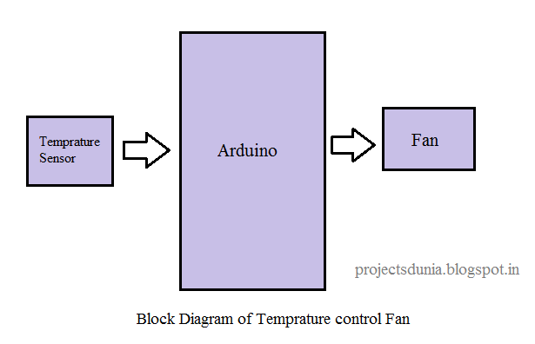

**COMPONENTS REQUIRED**

1. Arduino UNO microcontroller.

2. 16*2 LCD display.

3. 12v DC fan.

4. 9v battery.

5. LM35 temperature sensor.

6. 2N2222 transistor.

7. 10 uF capacitor.

8. Two 1k resistor.

9. 1N4007 diode

10. LED.

**INTRODUCTION**

With the advancement in technology, intelligent systems are introduced every day. Everything is getting more sophisticated and intelligible.There is an increase in the demand of cutting edge technology and smart electronic systems. Microcontrollers play a very important role in the development of the smart systems as brain is given to the system. Microcontrollers have become the heart of the new technologies that are being introduced daily. A microcontroller is mainly a single chip microprocessor suited for control and automation of machines and processes. Today, microcontrollers are used in many disciplines of life for carrying out automated tasks in a more accurate manner. Almost every modern day device including air conditioners, power tools, toys, office machines employ microcontrollers for their operation. Microcontroller essentially consists of Central Processing Unit (CPU), timers and counters, interrupts, memory, input/output ports, analog to digital converters (ADC) on a single chip. With this single chip integrated circuit design of the microcontroller the size of control board is reduced and power consumption is low. This project presents the design and simulation of the fan speed control system using PWM technique based on the room temperature. A temperature sensor has been used to measure the temperature of the room and the speed of the fan is varied according to the room temperature using PWM technique. The duty cycle is varied from 0 to 100 to control the fan speed depending upon the room temperature, which is displayed on Liquid Crystal Display.

**Temperature Sensor:**

We are using LM 35 as temperature sensor. LM 35 is a precision temperature sensor whose output is linearly proportional to Celsius Temperature. The LM35 is rated to operate from -55° Centigrade to 150° Centigrade with a linear scale factor of +10mv

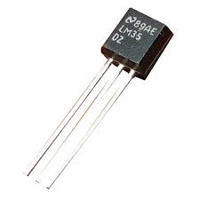I

Fig 1.1 LM35 sensor

**Liquid Crystal Display:**

The LCD is a dot matrix liquid crystal display that displays alphanumeric characters and symbols. 16X2 LCD digital display has been used in the system to show the room temperature. Liquid Crystal Display screen is an electronic display module and find a wide range of applications. A 16x2 LCD display is very basic module and is very commonly used in various devices and circuits. These modules are preferred over sevensegments and other multi segment LEDs.

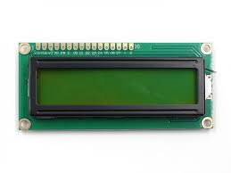

fig 1.2 LCD display

**Arduino UNO microcontroller:**

Arduino is an open-source electronics platform based on easyto-use hardware and software. Arduino boards are able to read inputs - light on a sensor, a finger on a button, or a Twitter message - and turn it into an output - activating a motor, turning on an LED, publishing something online. You can tell your board what to do by sending a set of instructions to the microcontroller on the board. To do so you use the Arduino programming language (based on Wiring), and the Arduino Software (IDE), based on Processing. Over the years Arduino has been the brain of thousands of projects, from everyday objects to complex scientific instruments.

A worldwide community of makers - students, hobbyists, artists, programmers, and professionals - has gathered around this open-source platform, their contributions have added up to an incredible amount of accessible knowledge that can be of great help to novices and experts alike.

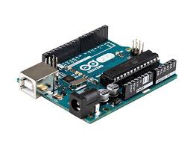

fig 1.3 Arduino UNO

**Diode 1N4007:**

A diode is an electronic device which allows current flow through only one direction and prevents bidirectional flow. That is the current should always flow from the Anode to cathode and not vice-versa. For 1N4007 Diode, the maximum current carrying capacity is 1A it with stand peaks up to 30A. Hence, we can use this in circuits that are designed for less than 1A. The reverse current through this diode is 5uA which is negligible. The dissipation power of this diode is 3W.This section gives a pure view description and extent of everything included in this Project Report. The purpose of this report is to give the complete and detailed information about our mini project. This document is primarily intended to anyone who wants to know about the automatic operation of switching on/off of the pump without manually switching it off.

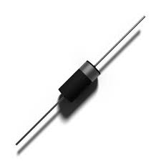

fig 1.4 Diode

**2N2222 Transistor:**

The **2N2222** is a common NPN (BJT) used for general purpose low-power amplifying or switching applications. It is designed for low to medium current, low power, medium voltage, and can operate at moderately high speeds. It was originally made in the TO-18 metal can as shown in the picture.

The 2N2222 is considered a very common transistor and is used as an exemplar of an NPN transistor. It is frequently used as a small-signal transistor and it remains a small general purpose transistorof enduring popularity.

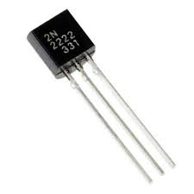

fig 1.5 Transistor

**LIST OF FIGURES**

FIG1.1-Temperature sensor

FIG1.2-Liquid crystal display

FIG1.3-Arduino UNO

FIG1.4-Diode 1N4007

FIG1.5-2N2222 Transistor

**CIRCUIT DIAGRAM**

Temperature Sensor

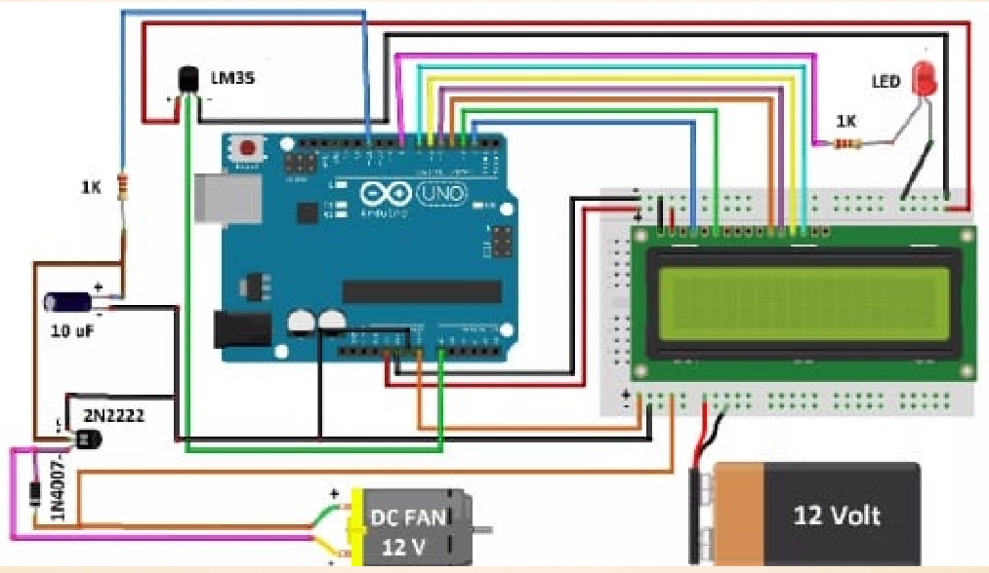

Resistor

LCD

Capacitor

Transistor

Diode

Arduino

Battery

**WORKING**

The aim of this project is to design a temperature controlled fan using 8051 microcontroller, in which the fan is automatically turned ON or OFF according. In this circuit, the LM35 temperature sensor will give continuous analog output corresponding to the temperature sensed by it. This analog signal is given to the ADC, which converts the analog values to digital values. The digital output of the ADC is equivalent to sensed analog voltage. In order to get the temperature from the sensed analog voltage, we need to perform some calculations in the programming for the microcontroller. Once the calculations are done by the microcontroller according to the logic, the temperature is displayed on the LCD. Like this, the microcontroller will continuously monitor the temperature. If the temperature exceeds more than 50 degree Celsius (as per the code), the microcontroller will turn on the relay to start the fan. If the temperature drops below 40 degree Celsius (as per the code).

The speed of the fan varies at different temperatures, i.e verified using app called RPM CHECKER.

|  |  |  |
| --- | --- | --- |
| **TIME** | **TEMPERATURE**  **(DEGREE CELCIUS)** | **SPEED(RPM)** |
| 11:30am | 32.6 | 33.38 |
| 2:30pm | 33 | 35 |
| 4:45pm | 31 | 29 |

**RESULT**

A temperature sensing automatic speed controller for fan has been designed and constructed according to the design.The speed controller has been tested in various temperature condition and successful results have been found with minimum error. Errors have been found by comparing experimental rpm and theoretical rpm of fan which is around 3.7%.

**APPLICATIONS**

Temperature based fan speed controller is useful for cooling the processor in the laptops and personal computers “more efficiently”. Generally fan in laptop comes with only two or three possible speeds. So it results in more power consumption. The fan designed in this project, has different values of speed according to temperature change. This can be also used in small scale industries for cooling the electrical/mechanical equipment. The whole circuit except motor and fan can be manufactured on a single PCB, and it can be used for temperature based control operations.

1. This project can be used in Home.

2. This project can be used in Industry.

3. This will help in saving the energy / electricity.

**ADVANTAGES AND DISADVANTAGES**

Advantages

1.It is very economical and easy to handle by the user.

2.Speed varies automatically, so that it controls the speed without using it manually.

3.It is very easy to install in offices, houses ect.

4.Saves energy by slowing down its speed in low temperature

Disadvantages

1.Micro controller is the heart of the circuit, if controller is damaged the whole system will be interrupted.

2.Speed control is independent of individual preference

**REFERENCES**

The following data for the project has been gathered from a number of sources. A list of few of the sources are:

1.<https://www.arduino.cc/en/Main/Software>

2.[www.ti.com/product/LM35](http://www.ti.com/product/LM35)

3.[www.learningaboutelectronics.com](http://www.learningaboutelectronics.com)

4.<https://components101.com/lm35-temperature-sensor>